**Description for website:**

**Minimum Temperature:**

Below are various graphs to help interpret what is happening to the predictor variable “Minimum Temperature”. We believe that minimum temperature affects how many people will be in the city (the variable to which we want to find out). In the first scatter plot, the minimum temperature tends to follow a sin graph with some Gaussian noise. There are seemingly some outliers on the warmer end and fewer outliers on the colder end. To find out more, the box plots by month shows this in detail.

The box plots of minimum temperature by month show a clear trend between each month. The coldest minimum temperatures as expected in Winter (June, July and August) and the hottest minimum temperatures in Summer (Especially January and February). What is interesting is visually confirming the outliers that were suspected in the previous graph. There are three minimum outliers in July, whilst there are many more maximum outliers throughout the year (especially in the summer months). This may suggest more heat events (heat waves) than cold ones.

When looking at the histogram, it is clear that our observations from the previous two graphs are substantiated. With a skew of 0.23, this shows more outliers on the maximum end than the minimum end.

The prediction neatly follows the same trend as the actual values. As such, it will be reliable when calculating the pedestrian counts.

**Maximum Temperature:**

Below are various graphs to help interpret what is happening to the predictor variable “Maximum Temperature”. We believe that maximum temperature affects how many people will be in the city (the variable to which we want to find out). In the first scatter plot, maximum temperature tends to follow a sin trend but heavily weighted towards maximum values. To find out more, the box plots by month shows this in detail.

The box plots of maximum temperature by month show a clear trend between each month. What is interesting to note is that there are large maximum whiskers meaning that there are quite significant temperature variations leaning towards the hotter side. For example, in January one-quarter of the temperatures lie between 30 $°$ C and 43 $°$ C. This confirms the observation from the previous graph that there is a skew towards higher temperatures, which may suggest that heatwaves are frequent.

When looking at the histogram it is clear that our observations from the previous two graphs are substantiated. With a skew of 0.86 this shows the clear skew towards higher temperatures.

The prediction neatly follows the same trend as the actual values. As such it will be reliable when calculating the pedestrian counts.

**Prediction:**

The prediction was made by using various weather variables and calendar data (day of the week, public holidays etc.) With an R2 of 0.21 this shows that the prediction is weak and perhaps should not be used in decision making. The prediction has been heavily influenced by the previous year’s data and could be considered as a negative outlook or a minimum benchmark. As Covid-19 has been an unprecedented event and rolling restrictions have been applied at random times it is extremely difficult to predict. Whilst having more access to data would be beneficial to the model it may ultimately become fruitless as there are too many unknowns.

**Predicting Maximum and Minimum Temperature**

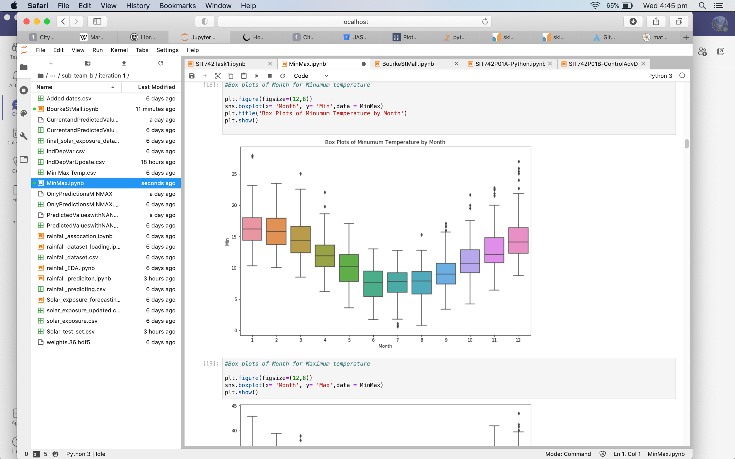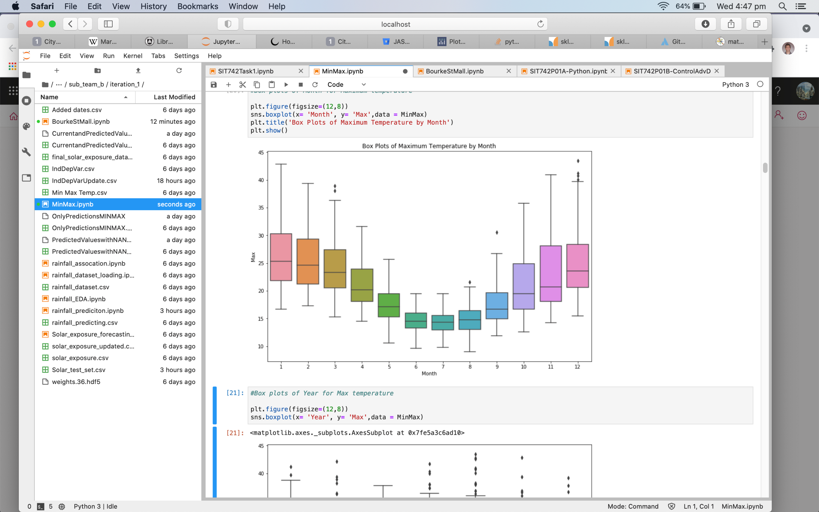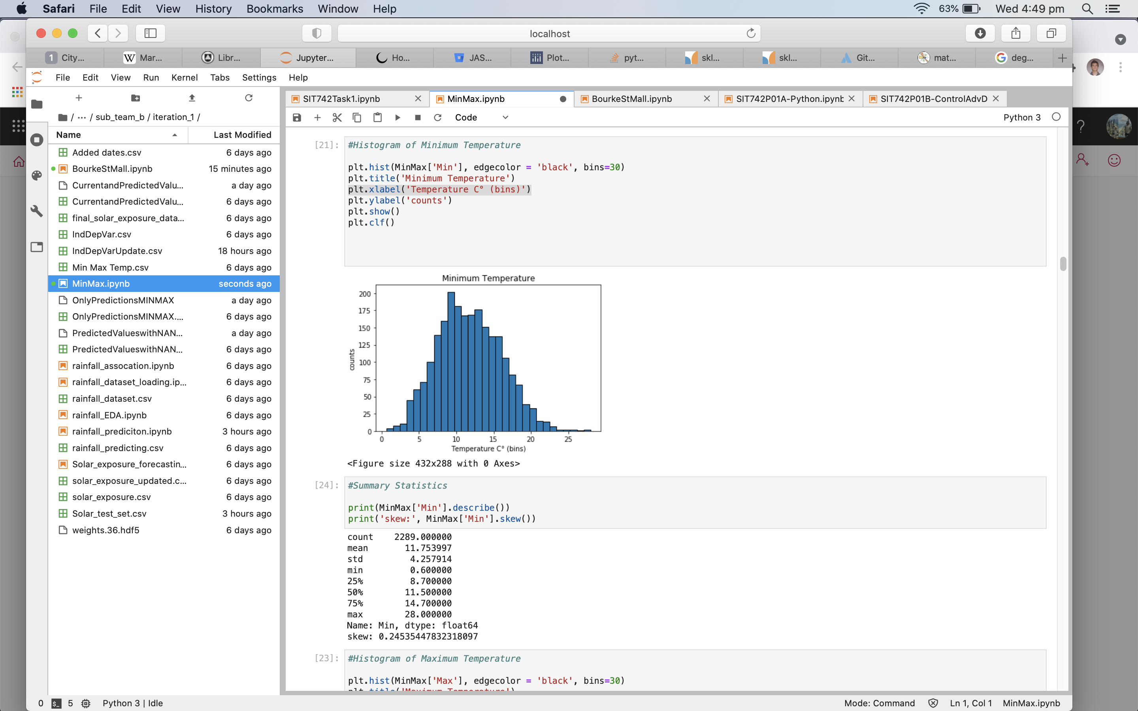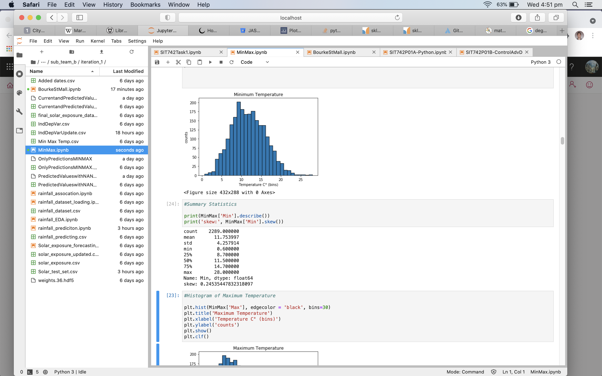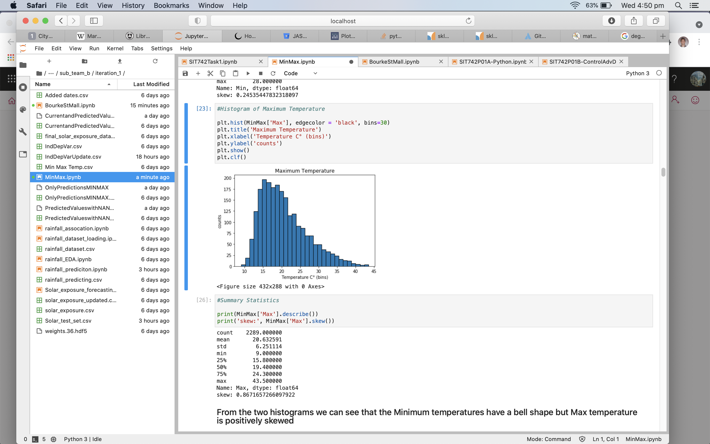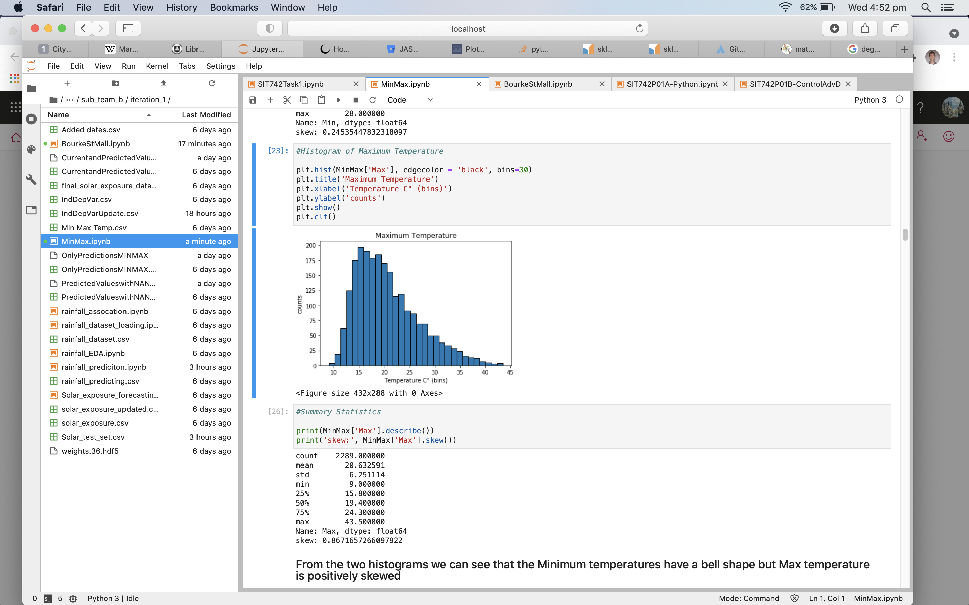

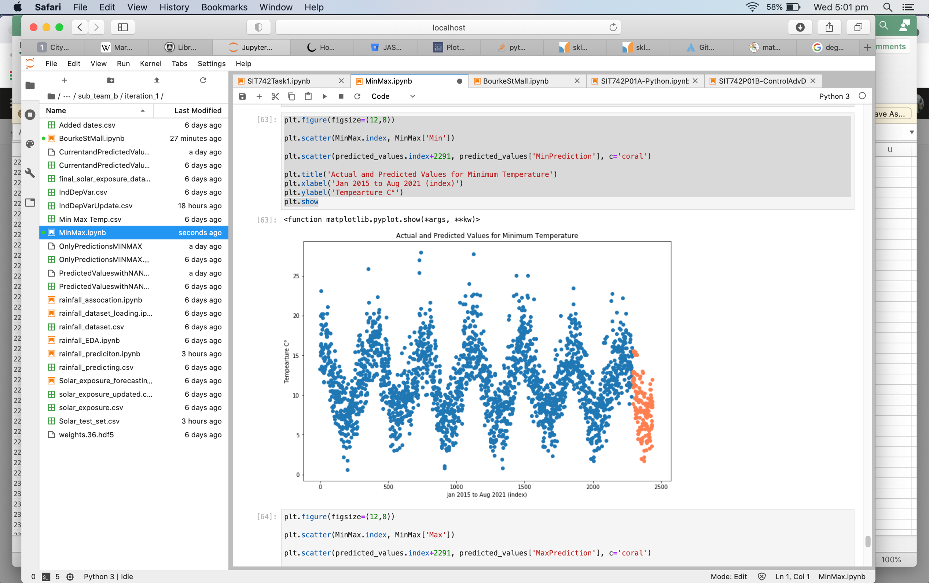

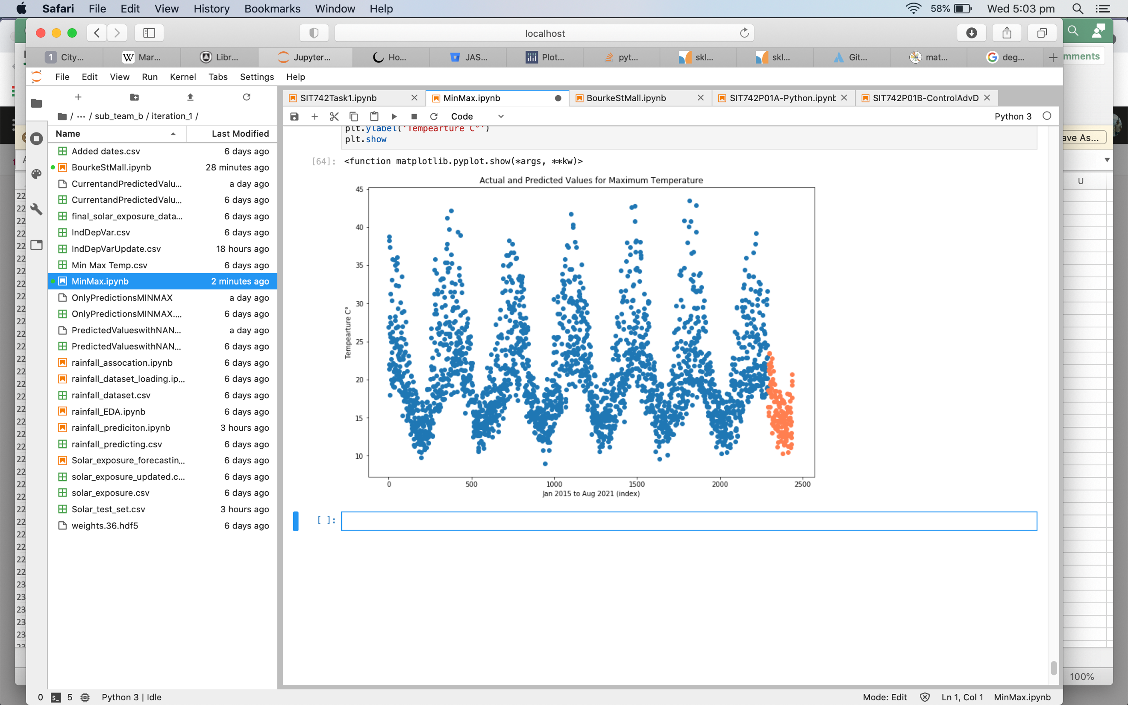

**PREDICTING BOURKE STREET MALL**

